Mandatory Field Check

Definition
# Source: AI Source: Provided by: [Data Path: Persons Table -> ID Column: 1, Name_En Column: Motasem Essam] -> From: [Chatgpt (GPT‑5 Mini)] on [12/10/2025]
Mandatory Field Check ensures that essential fields in a dataset or form are not left empty.
- It prevents missing data in critical columns that are required for processing, analysis, or decision-making.
- Often applied to fields like Name, ID, Email, Date of Birth, or Product Code.

Key idea:
# Source: AI Source: Provided by: [Data Path: Persons Table -> ID Column: 1, Name_En Column: Motasem Essam] -> From: [Chatgpt (GPT‑5 Mini)] on [12/10/2025]
It’s like making sure you cannot submit a form without filling in all required fields.

Characteristics
# Source: AI Source: Provided by: [Data Path: Persons Table -> ID Column: 1, Name_En Column: Motasem Essam] -> From: [Chatgpt (GPT‑5 Mini)] on [12/10/2025]
- Validates that specific fields contain data before saving or processing.
- Ensures critical information is always captured.
- Can be implemented in databases, spreadsheets, web forms, and applications.
- Often combined with format or range checks for more robust validation.

Examples
# Source: AI Source: Provided by: [Data Path: Persons Table -> ID Column: 1, Name_En Column: Motasem Essam] -> From: [Chatgpt (GPT‑5 Mini)] on [12/10/2025]
- Student Registration Form
- Name: Ali ✅
- Student ID: 101 ✅
- Class: ❌ (empty, violates mandatory field check)
- Employee Database
- Employee Name: Sara ✅
- Employee ID: 205 ✅
- Department: ❌ (cannot leave blank)
- Online Signup Form
- Email: user@example.com ✅
- Password: ❌ (mandatory field not filled, form submission blocked)
- Product Inventory
- Product Name: Laptop ✅
- Product Code: P001 ✅
- Price: ❌ (mandatory field missing, cannot add product)

Advantages
# Source: AI Source: Provided by: [Data Path: Persons Table -> ID Column: 1, Name_En Column: Motasem Essam] -> From: [Chatgpt (GPT‑5 Mini)] on [12/10/2025]
- Ensures critical data is always captured.
- Prevents incomplete records that may cause errors in processing or analysis.
- Improves data quality and reliability.
- Essential for forms, registrations, and database entry.

Disadvantages
# Source: AI Source: Provided by: [Data Path: Persons Table -> ID Column: 1, Name_En Column: Motasem Essam] -> From: [Chatgpt (GPT‑5 Mini)] on [12/10/2025]
- Can block entry if the user forgets to fill mandatory fields, causing delays.
- May increase user frustration for long forms with many required fields.
- Requires careful design to avoid marking non-essential fields as mandatory.
- Cannot verify correctness of data, only that it exists.

Example Section
# Source: AI Source: Provided by: [Data Path: Persons Table -> ID Column: 1, Name_En Column: Motasem Essam] -> From: [Chatgpt (GPT‑5 Mini)] on [12/10/2025]
A school database for new students:
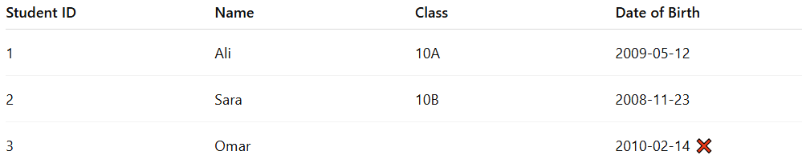
Student ID | Name | Class | Date of Birth
1 | Ali | 10A | 2009-05-12
2 | Sara | 10B | 2008-11-23
3 | Omar |  | 2010-02-14 ❌
- Omar’s Class field is empty.
- The system flags the record and prevents saving until the mandatory Class field is filled.

I can continue with Validation Check 6: Cross-Field Check next, keeping the same structured format so you’ll have the full set of validation checks.
Do you want me to continue?

